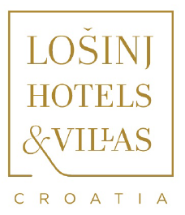
NEW AROMA RETREAT ON CROATIA’S ‘ISLAND OF VITALITY’
Lošinj Hotels & Villas Launches 4-day Aromatherapy Workshop for Essential Summer Revitalisation
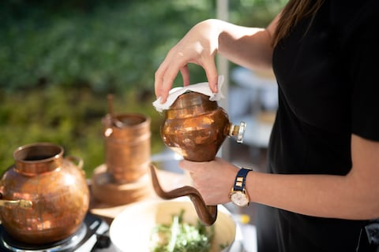
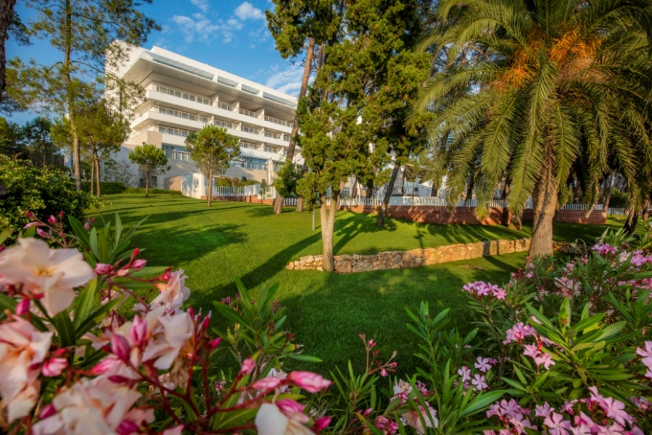
1 July 2019: Lošinj Hotels & Villas’ award-winning Hotel Bellevue has launched a four-day, hands-on Aromatherapy Workshop Retreat, inviting guests to harness the therapeutic benefits of Lošinj’s fragrant natural garden. The new retreat offers a rare glimpse into the art of essential oil distillation – from concept and inspiration, to the extraction of the oils to create unique aromatherapy products to take home. In tandem, guests can enjoy detoxifying treatments at the award-winning Bellevue Spa Clinic; prepare local gourmet delicacies using the finest Mediterranean flavours and island herbs; explore endless walking and hiking trails in the fragrant fresh air of the ‘Island of Vitality’; and visit Lošinj’s renowned Garden of Fine Scents.

Declared a natural health resort at the end of 19th Century by Viennese medical experts, the island of Lošinj has been recognised for its rehabilitative properties for over 120 years, notably for its unique Mediterranean microclimate and abundant untouched nature. This reputation owes much to the vision of Croatian Professor and Botanist Ambroz Haračić, who planted over 80,000 Aleppo pines and 500 Avenue trees in the first year of a major afforestation programme in 1886, and 300,000 seedlings every year to follow. Today, the rich natural wealth of Lošinj, and neighbouring Cres, are the inspiration behind Hotel Bellevue’s latest wellness offering. The islands are home to over 1,200 herb species; 939 of these are indigenous, while about 80 were introduced by the islands’ famous globetrotting sailors - including Mexican cacti and agave, Indian figs, Japanese medlar and eucalyptus. 230 of the plant species are noted for their medicinal benefits. A nurturing experience for all the senses, the new four-day Aroma Workshop Retreat invites guests to harness the therapeutic properties of the island’s herbal bounty to improve physical, mental and emotional wellbeing.
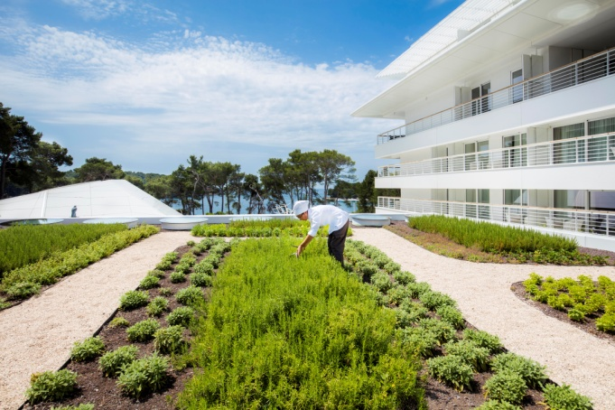
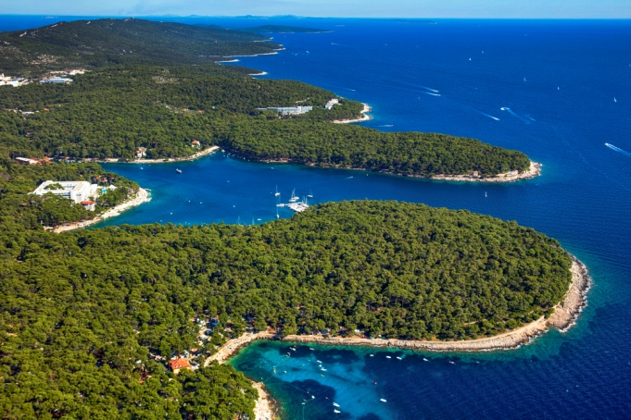

With a professional guide, the journey begins by exploring the local pine forests of Čikat Bay to identify and pick a selection of organic herbs, learning about their exquisite aromas and natural healing properties along the way. Back in the tranquil gardens of the Bellevue Spa Clinic, participants will learn how to prepare the ingredients and extract the oils using a bespoke essential oil distilling process to create face creams, body peeling scrubs, facial masks and lip care products to take home. Discovering the therapeutic properties of the essential oils that have been hidden from the outside world for generations, guests will enjoy a detoxifying massage and aromatherapy face treatment using the homemade creams and aromatic oil blends.
The Aromatherapy journey continues into the kitchen with a cookery class using the freshest Mediterranean ingredients seasoned by the island’s rich herbs and olive oil; an outdoor yoga class in the aromatic embrace of the island; and a visit to Lošinj’s Garden of Fine Scents – a nursery of the island’s medicinal herbs.
Hotel Bellevue’s four-day Aroma Workshop Retreat starts from €520 (approx. GBP462) per person, excluding accommodation and food. The Retreat includes: a walk through Čikat Bay picking, recognising and learning about the island’s herbs; preparation of plants for extraction and learn the benefits of different aroma oils; extraction of oil and production of balm, tonic and face mask; one cooking class with local ingredients and herbs; a visit to the Lošinj Aromatic Garden; one Detox Massage and one Aromatherapy face treatment; a two hour hike with a local guide to explore the island; and two group Yoga sessions.

Hotel Bellevue offers four nights Superior Atrium accommodation from €816 (approx. GBP732) based on two adults sharing on a B&B basis, excluding tax and service. For reservations and further information visit www.losinj-hotels.com/en/hotels-and-villas/hotel-bellevue, email: bellevue@losinj-hotels.com or call tel: +385 51 661 101.

For reservations and further information visit www.losinj-hotels.com/en/hotels-and-villas/hotel-bellevue, email: bellevue@losinj-hotels.com or call tel: +385 51 661 101.

Lošinj Hotels & Villas’ luxury portfolio also includes the five-star Boutique Hotel Alhambra and three five-star villas, Villa Augusta, Villa Mirasol and Villa Hortensia. All are ideal for indulgent getaways, active breaks and family holidays.

-ENDS-
Notes to editors:
A relatively undiscovered jewel to the north of Croatia, the intimate Adriatic island Lošinj – ‘island of vitality’ - is famed for its rich nature; counting more than 1200 aromatic and healing herbs, more than 2600 hours of sunshine every year and the cleanest seas. At the end of 19th century, Lošinj was recognized as a ‘healing location’ due to its unique microclimate. Set in the idyllic Čikat Bay and dotted amongst the pine forests, Lošinj Hotels & Villas boasts two five star hotels (Hotel Bellevue and Boutique Hotel Alhambra) and three five star villas (Villa Augusta, Villa Mirasol and Villa Hortensia) – ideal for luxurious getaways, active breaks, family holidays and more. Passing through a comprehensive renovation in 2014 and an upgrade of Bellevue Spa Clinic in 2018, the group’s wellness resort Hotel Bellevue offers fully integrated health programmes, extensive spa facilities and beauty treatments by world-famous French podiatrist Bastien Gonzalez, 45 Degrees, Forlle'd Japan, Pharmos Natur and Valmont facials.

Lošinj is reached by private plane or luxury car transfer from all many European airports (namely Ljubljana, Pula, and Zagreb). Silver Air offer direct scheduled flights to Lošinj, from Venice, Zagreb and Lugano. www.silverairtravels.com

For more information or to discuss feature ideas and press trip opportunities, please contact:
kate@bacall.net, sarah@bacall.net, nat@bacall.net or flora@bacall.net at Bacall PR. Tel: +44 (0)20 7630 2880.

