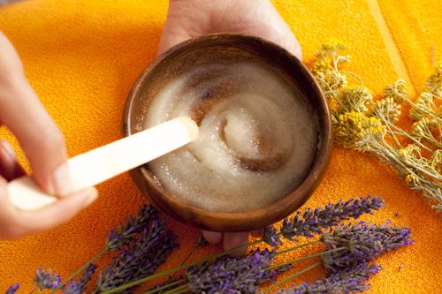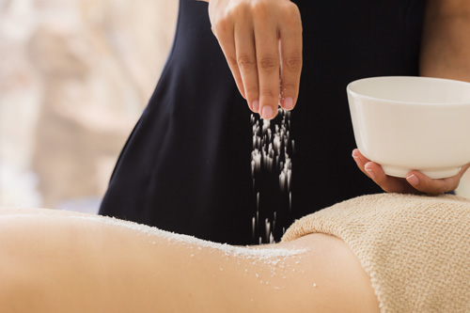

DIY Home Spa & Skincare Products

Body Scrub

Exfoliation techniques involves slight pressure and circulatory motions which increases blood circulation that has many benefits such as:
- promoting new skin cell production
- breaking down fat tissues
- helping to rid the body of toxins
- healing and preventing ingrown hairs (by removing the top layer of skin, exfoliation can assist not only in getting rid of ingrown hairs, but also revealing the newer skin underneath)

This full body exfoliation treatment is great if you want to diminish the appearance of dry, sallow skin or alleviate keratosis pilaris (chicken skin). Benefits from this type of treatment can last up to 30 days, especially if you follow a good homecare regimen.

Ingredients:
- 2 tablespoons of honey
- 2 - 3 tablespoons of olive oil (or any body balm)
- 2 - 3 tablespoons of sea salt
- 1 - 2 drops essential oil if you want to scent it (to be added last)

Instructions:
- Mix the honey and olive oil in a ceramic bowl or glass jar
- Slowly add the sea salt into the mixture
- Add the essential oil just before the treatment and mix well

This mixture should be of a consistency of a granular paste; if it is not granular enough, add more sea salt. Warm the bowl up for 60 sec in the microwave before using, or keep bowl it in hot water for 10 mins. It should be warm. Leftover scrub paste can be kept in a tightly closed jar for up to 30 days in a cool and dark place.

Massage with an exfoliator in circular motions. Start from feet up on one side of your body, then move to the other.

Moisturize the skin with cream or body oils.

Try also…

Face Scrub

Grind 2-3 tablespoons of rice into a powder in a blender and mix that with 3-4 tablespoons of coconut oil or olive oil. Gently exfoliate your face in circular motion with the mixture and rinse it off with warm water.

Collagen Mask

Dissolve a packet or sheet of gelatin in a teacup of warm water. Apply it with a brush onto the whole face, neck and neck collar and leave that on for about 20 mins, then rinse it off with warm water.

Aloe Vera Mouth Rinse

Before bed after brushing your teeth, take small and slow sips of freshly squeezed or bottled aloe vera juice (about 25 ml) and keep that in your mouth for a while before swallowing it. Not only does that clean your tongue and gums, it also helps to regenerate all your mucous membranes overnight.

